Move Head Pan and Tilt with ESP32-CAM Face detection Facility

Table of Contents
1 MoveHead_ESP_V2.1 2
1.1 Programming ESP32_CAM 2
1.2 Install Arduino board and Libraries 3
1.3 Compile and upload to board 6
1.4 Creating an I2C data bus 7
1.5 OLED display 9
1.6 Connecting Servo 10
2 Future development 13

MoveHead_ESP_V2.1
Note: This module uses Espressif version 1.0.4. Updating to the latest version is a "Big Job" which requires hardware and software upgrade. This is why we are currently using the old method.
(See Future Development section)
Between version 1.0.4 and now, Espressif completely restructured their face detection libraries:
The default "espressif32" platform is version 3.0, 6.0, or higher and this code requires the file fd_forward.h which effectively doesn't exist in the same place anymore.
1. PLATFORM VERSION: Fixed at espressif32@1.12.4 in platformio.ini to ensure compatibility with legacy ESP-FACE (v1.0.4) headers (like fd_forward.h).
2. FUNCTION PROTOTYPES: Unlike Arduino IDE, VS Code requires all functions to be declared at the top of the file before they are called.
3. TYPE MATCHING: Function return types in prototypes MUST match the actual definitions (e.g., getMilliVolt must be consistently 'int' or 'float').

Programming ESP32_CAM
The ESP32-CAM has not got a USB loader and we need a separate FTDI loader
Setting up the FTDI to programme the ESP32-CAM
https://randomnerdtutorials.com/program-upload-code-esp32-cam/

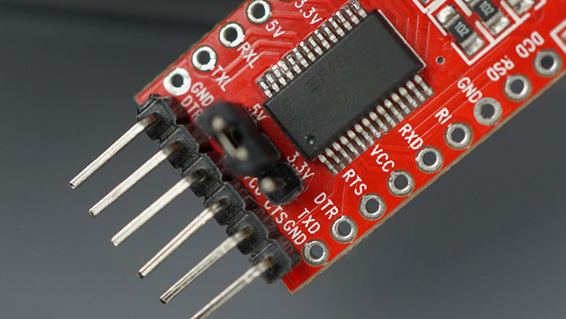
The jumber on the FTDI needs to be on 5V setting for Arduino.
Also GPIO 0 needs to be connected to GND to put the ESP32 into programming mode so that you’re able to upload code.
Once the code is uploaded it needs to be disconnected so that the ESP32 gets to normal mode.

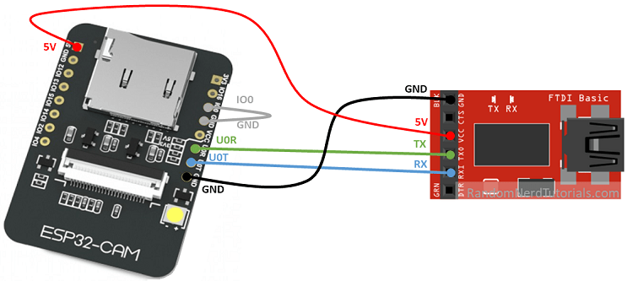

ESP32-CAM | FTDI Programmer
GND | GND
5V | VCC (5V)
U0R | TX
U0T | RX
GPIO 0 | GND

Install Arduino board and Libraries
To install the ESP32 board in your Arduino IDE, follow these next instructions:
- In your Arduino IDE, go to File> Preferences
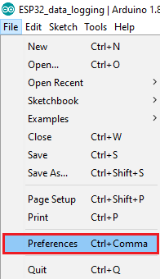

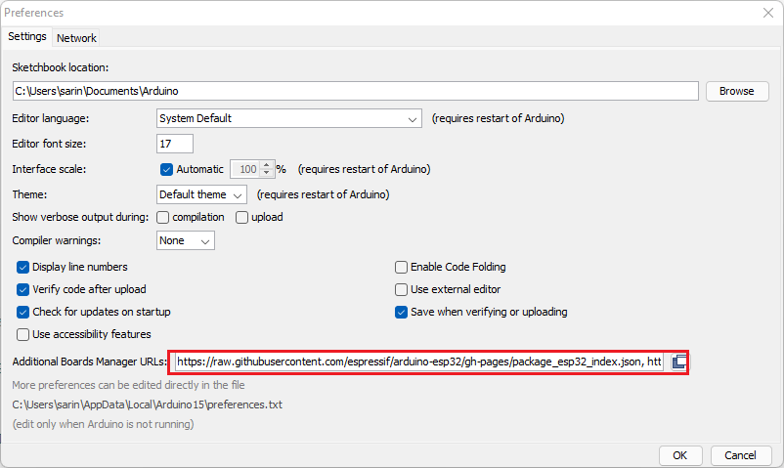
Note: if you already have the ESP8266 boards URL, you can copy and paste the follows:
https://raw.githubusercontent.com/espressif/arduino-esp32/gh-pages/package_esp32_index.json, http://arduino.esp8266.com/stable/package_esp8266com_index.json
There are a bit of differences between the new version and the old version that is on the instructions
1- Need to install ArduinoWebsockets version 0.5.3 library before compiling

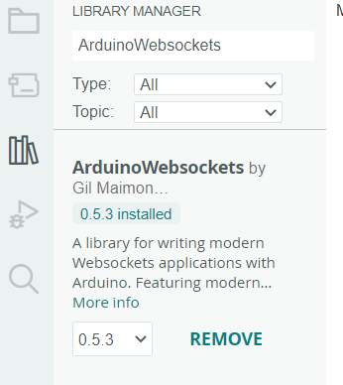

- Open the Boards Manager. Go to Tools > Board > Boards Manager…
- Search for ESP32 and press install button for the “ESP32 by Espressif Systems“:
The second is the board that needs to be an older version 1.0.4 as the new version has been altered too much and doesn’t have most of the functions.

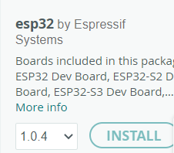

and finally selected board AI thinker ESP32-CAM with the correct COM serial port.

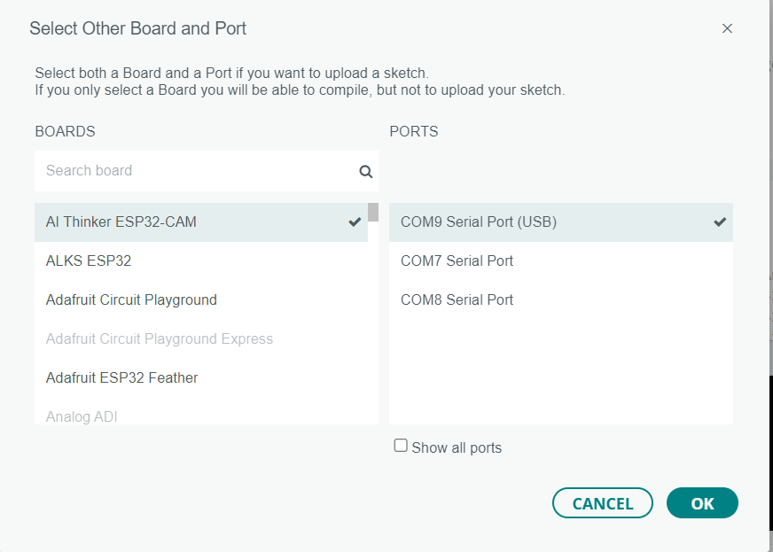

The original instructions needed the following two .h files from the link.https://robotzero.one/face-tracking-esp32-cam/
camera_index.h
camera_pins.h

however the latest code version MoveHead_ESP_V1_7.ini don’t uses the camera_index.h as it is for the web server and the camera_pins.h is included in the current code.

Compile and upload to board
To Compile and upload we need to connect the switch (pin IO0 and Ground) and press the back button on ESP32-CAM board first.
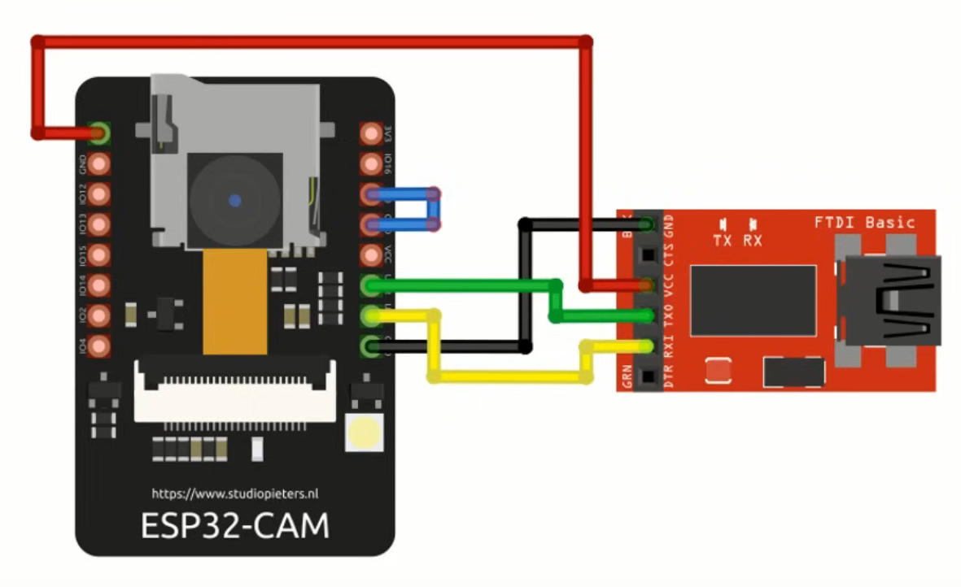

If everything went as expected, you should see a “Done uploading.” message.
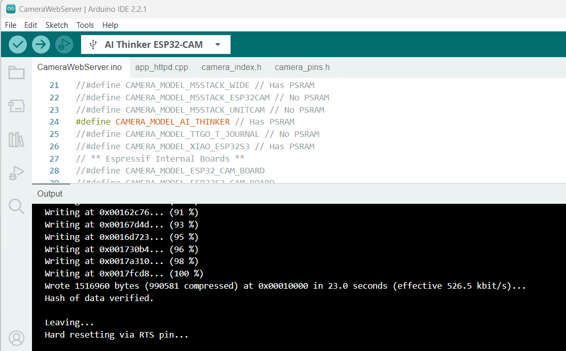
Now disconnect the jumber pin between IO0 and Ground and press the reset button on the board.
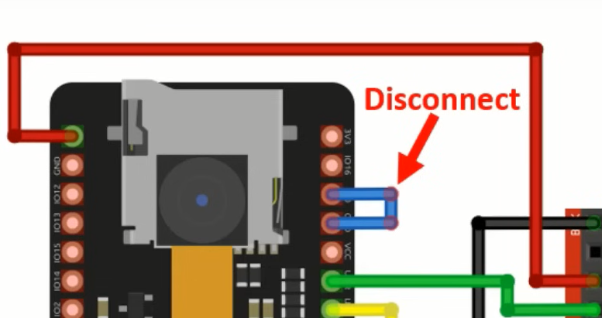
Unplug the USB and plug again to reset the camara
Open the Arduino IDE Serial Monitor at a baud rate of 115200.

Creating an I2C data bus
The I2C library calls for the two I2C GPIO 22 (SCL) and GPIO 21 (SDA) that are already utilised by the camera, therefore we need alternative way of creating the I2C pins on another two IO pins.
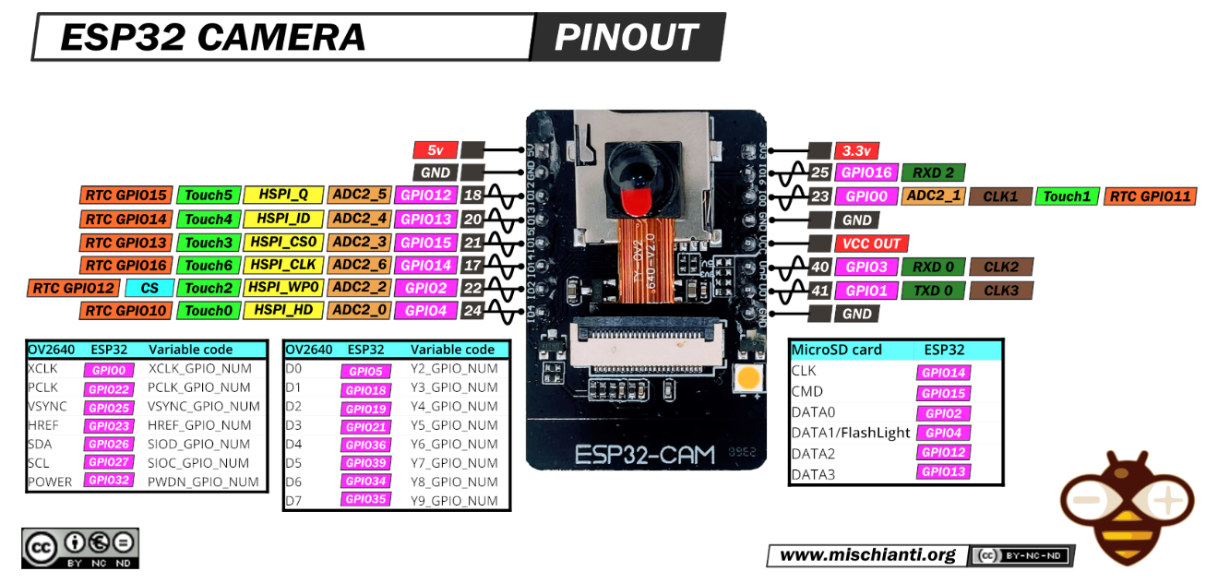

https://github.com/abish7643/ESP32Cam-I2CSensors
// Define SDA and SCL Pins, Pin Number 14 and 15 are selected respectively.

#define I2C_SDA 15
#define I2C_SCL 14
// Create a Two Wire Instance.

TwoWire I2CSensors = TwoWire(0);
// In setup(), intialize the Two Wire Instance by passing in the SDA & SCL Pins and the clock frequency.

I2CSensors.begin(I2C_SDA, I2C_SCL, 100000);
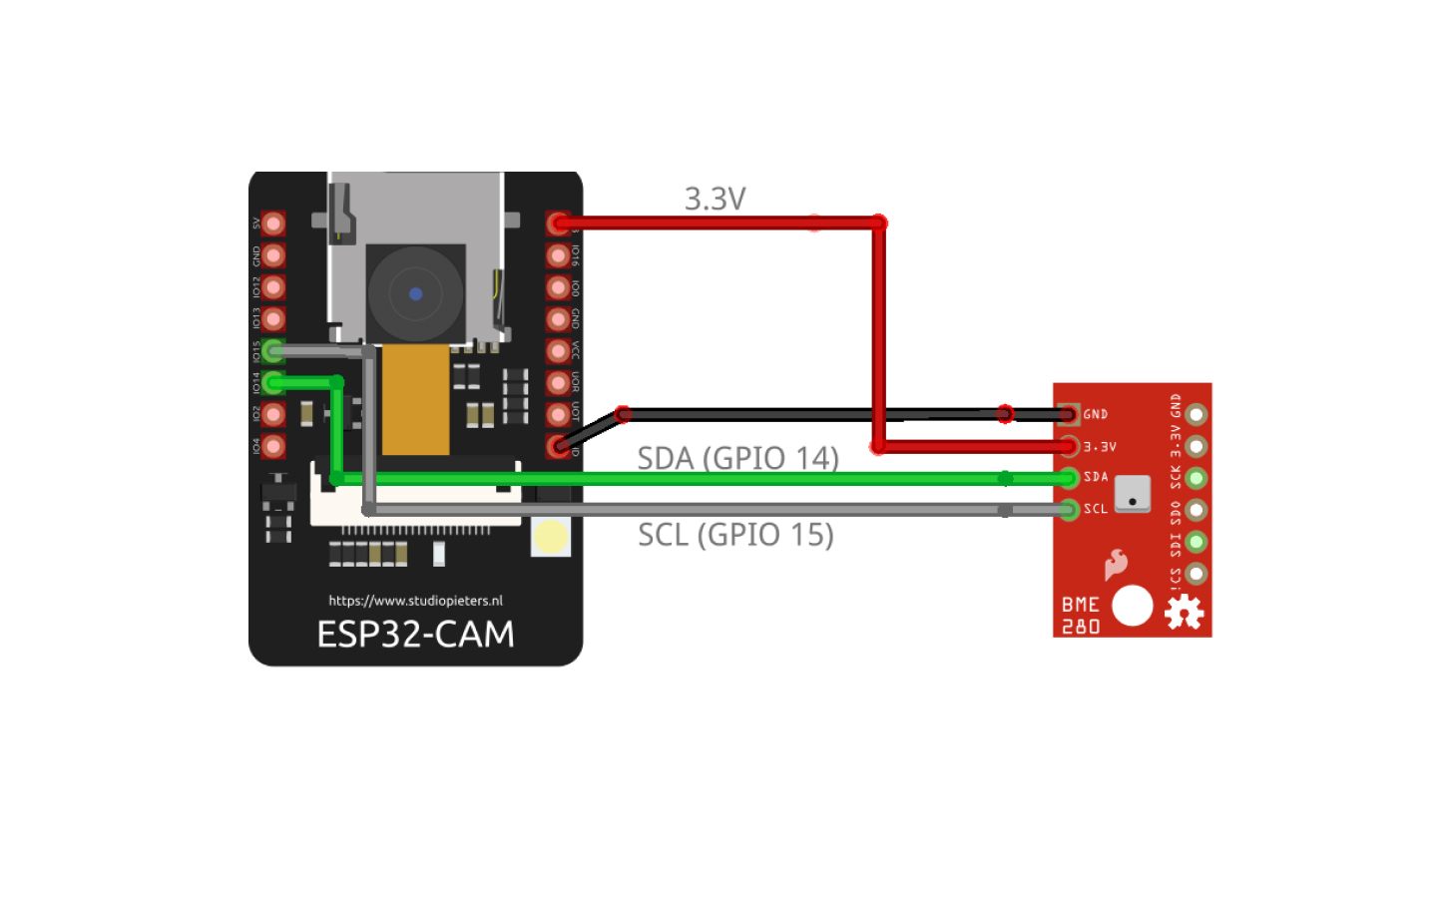

OLED display
The OLED display uses I2C to connect and some of the Arduino libraries does not appear to work on ESP32-CAM.
The following code is an example of using the OLED on ESP32-CAM
#include <Adafruit_GFX.h> // Adafruit GFX Library Ver 1.11.9
#include <Adafruit_SSD1306.h> // Adafruit SS1306 by Adafruit Library Ver 2.5.9

// ESP32-CAM doesn't have dedicated i2c pins, so we define our own. Let's choose 15 and 14
#define I2C_SDA 15
#define I2C_SCL 14
TwoWire I2Cbus = TwoWire(0);

// Display defines
#define SCREEN_WIDTH 128
#define SCREEN_HEIGHT 64
#define OLED_RESET -1
#define SCREEN_ADDRESS 0x3D
Adafruit_SSD1306 display(SCREEN_WIDTH, SCREEN_HEIGHT, &I2Cbus, OLED_RESET);

void setup()
{
Wire.begin(15, 14); // SDA on GPIO15, SCL on GPIO14

// Initialize I2C with our defined pins
I2Cbus.begin(I2C_SDA, I2C_SCL, 100000);
Serial.println("Initialize display");

// SSD1306_SWITCHCAPVCC = generate display voltage from 3.3V internally
if(!display.begin(SSD1306_SWITCHCAPVCC, SCREEN_ADDRESS))
{
Serial.printf("SSD1306 OLED display failed to initalize.\nCheck that display SDA is connected to pin %d and SCL connected to pin %d\n", I2C_SDA, I2C_SCL);
while (true);
}

display.clearDisplay();
display.setTextColor(WHITE, BLACK);
display.setCursor(0, 0);
display.setTextSize(2);
display.setTextColor(SSD1306_WHITE);
display.print("Initialise");
display.display();

Note that you need to run display.display(); to show anything on the display.
The line display.setTextColor(WHITE, BLACK); ensures that the text gets clear when you write over it.

Connecting Servo
There are instructions to connect the servos directly to the ESP32-CAM using Pins IO 12 and IO2.
https://robotzero.one/pan-and-tilt-control-for-an-esp32-cam/

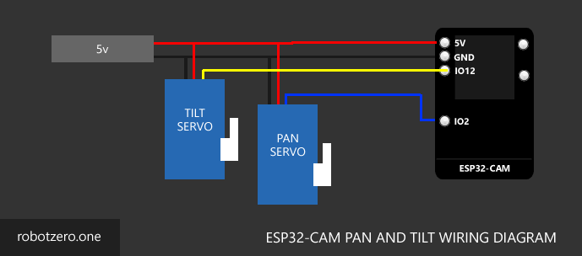
and also this
https://randomnerdtutorials.com/esp32-cam-pan-and-tilt-2-axis/
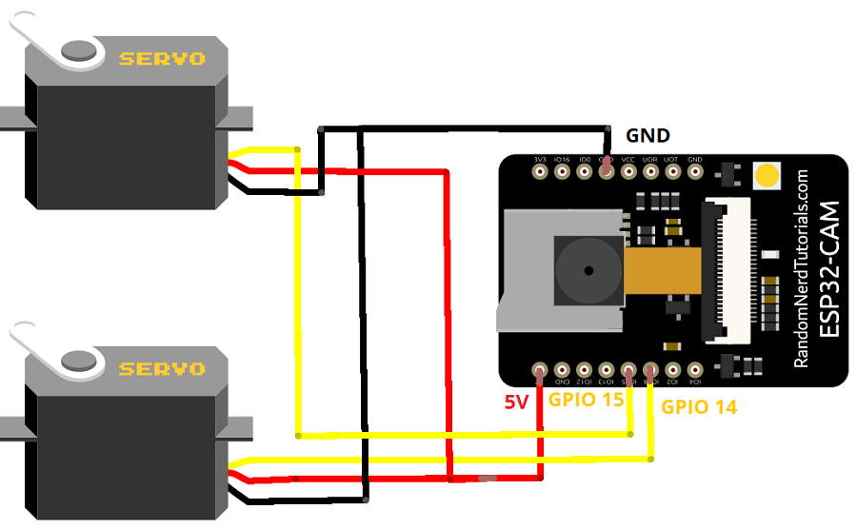

It appears that with either of these methods the servo interferes with the camera and as soon as the X Y coordinates of the face is detected, the boards reset itself.
It seems that the XY coordinates are transferred correctly via the I2C bus. Initially the voltage converter was used to separate the lines to see is the servos could work without additional board, however it seems that the servos need to be on a completely different circuit.
PCA9685 16-Channel 12-bit PWM Servo Driver I2C Interface is used to isolate the two circuits and it seems that this method works ok.
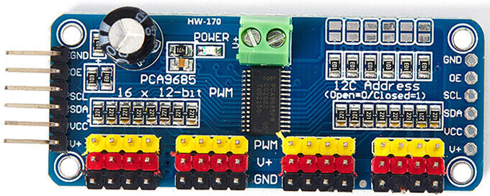
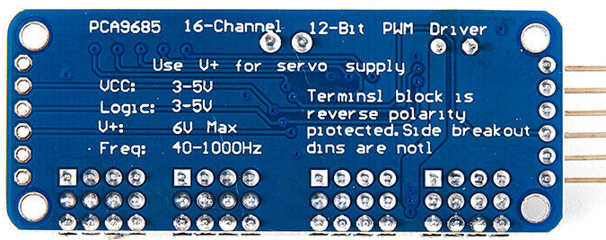

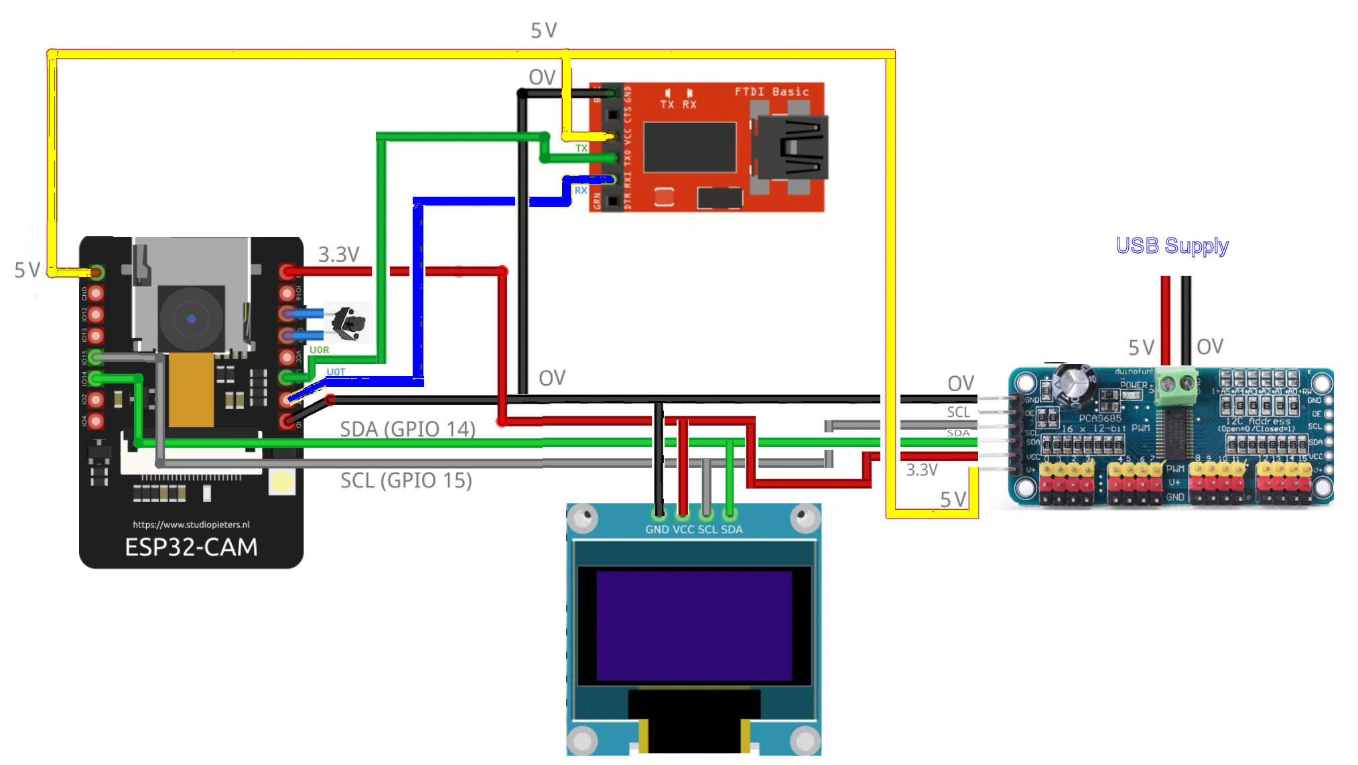

Future development
Update to the latest version of the espressif32 platform (currently v6.x+), requires a major shift in how the face detection is handled.
Espressif moved away from the old esp-face (which used fd_forward.h) and transitioned to a much more powerful (but more complex) library called ESP-DL (Deep Learning).
The Major Changes Required
1- Header Changes: You would replace #include "fd_forward.h" with #include "dl_detect_mnp01.hpp" (or the newer human_face_detect).
2- Namespace: ESP-DL is written in C++, so you’ll see dl:: namespaces and classes instead of the simple C-style structs.
3- Model Loading: In the new version, the "model" (the brain that recognizes faces) needs to be initialized as an object.
4- Matrix Types: dl_matrix3du_t has been replaced by Tensor or fb_data_t types depending on the specific version of the SDK.
How the New Code Structure Looks
If you were to use the ESP-WHO (the modern framework for the ESP32-CAM), your detection loop would look more like this:
// NEW LIBRARIES (Example for ESP-DL)
#include "esp_camera.h"
#include "human_face_detect_msr01.hpp" // Modern face detection
// Inside Loop
auto res = face_detector.infer(image_matrix); // Modern inference
if (res.size() > 0) {
// Face found!
int x = res[0].box[0];
int y = res[0].box[1];
// ... move servos
}
Here is a quick comparison to help you decide:
Feature | Legacy (Your Current) | Latest (Modern ESP-DL)
Setup | Simple, "Just works" with old core | Complex, requires many dependencies
Speed | Moderate (Fast enough for servos) | Significantly faster (optimized for ESP32-S3)
Accurac | Good for close-up face | Much better at distance and angle
Maintenance | Hard to find online help now | The current standard for new projects
It's a "Big Job", this is why we are currently using the old method
Rewriting isn't just changing a few lines; it's a structural overhaul. Because the newest libraries are designed for the ESP32-S3 (the successor to your board), running them on the original ESP32 AI-Thinker often requires careful memory management because the newer AI models are "heavier."
Moving to the ESP32-S3 is a game-changer for computer vision. The S3 chip features "AI Vector instructions" (essentially a built-in accelerator for math) that make face detection significantly more robust.
To bring this project "up to speed" with the latest espressif32 platform and ESP-DL (Deep Learning) libraries, we need to shift our approach.
1. Hardware Upgrade: ESP32-S3-Sense
To get those distance and speed improvements, we need the ESP32-S3-CAM (often called the S3-Sense). It has more pins, more power, and specifically designed hardware for the modern AI models.
2. The New Software Stack
In the latest environment, the fd_forward.h is replaced with the ESP-DL library. This uses a model called MSR01 (Multi-scale Recognition), which is much better at finding small faces further away from the lens.
3. Updated platformio.ini
For a new project, you would use the modern platform settings. Note that we no longer need to "pin" the version to an old core.
[env:esp32s3cam]
platform = espressif32
board = esp32-s3-devkitc-1 ; Or your specific S3 CAM board
framework = arduino
monitor_speed = 115200
build_flags =
-D CORE_DEBUG_LEVEL=3
-D BOARD_HAS_PSRAM
4. How the New Logic Works (Conceptual)
Instead of the old matrix logic, the modern code uses a "Detector" object. Here is the high-level flow of how we will rewrite your loop():
Capture: Grab the frame from the camera.
Convert: Turn the JPEG/YUV frame into an RGB888 Tensor (The new data format).
Infer: Run the human_face_detect function.
Result: This returns a list of "Keypoints" (Eyes, Nose, Mouth) and a "Bounding Box."
Servo Move: We take the center of that Bounding Box and map it to your servos exactly like we did before.
5. Why it's better at distance
The old mtmn_config we were using had to be manually tuned for "min_face" size. If a face was too far away (small), the math would simply ignore it to save CPU cycles.
The new MSR01 model in the S3 framework uses a "Feature Pyramid." It looks at the image at multiple scales simultaneously. This means it can "see" a tiny face in the distance just as easily as a large face right in front of the camera.
Wiring Changes
The ESP32-S3-Sense (and most S3-CAM modules) actually has more available GPIOs than the original AI-Thinker, but because the camera and the SD card slot eat up so many pins, you have to be strategic.
The I2C Advantage (OLED and PWM Driver) In the current project, are using an Adafruit PWM Servo Driver (PCA9685). This is the "secret weapon" for pin management.
OLED + PWM Driver: Both use I2C. Since I2C is a bus, we can connect both the OLED and the PWM Driver to the same two pins (SDA and SCL).
The Result: We only use 2 pins to control the OLED and up to 16 servos.2. The GPIO Count
On a typical ESP32-S3-CAM (like the Freenove or Seeed Studio versions), after the camera is connected, we usually have about 8 to 10 accessible pins left.

Component | Pins Needed | Connection Method
OLED Display | 2 | I2C (Shared)
PWM Servo Driver | 0 (Shared) | I2C (Shared)
3 Servos | 0 | Connected to the PWM Driver, not the ESP32
ADS1115 (Feedback) | 0 (Shared) | I2C (Shared)

Total Pins Used: 2.
There will be plenty of pins left over for other things (like buttons, LEDs, or sensors).
Power is the real bottleneck
The S3-CAM has enough pins, but it rarely has enough current.
The Problem: The S3 chip and the Camera together can pull over 500mA during AI face detection. If you try to power the three servos and the ADS1115 from the ESP32's 5V/3.3V pins, the board will likely "brownout" (reboot) the moment the servos move.
The Solution: Use an external 5V power supply to the V+ pin of your PCA9685 PWM driver to feed the servos, and just share the Ground (GND) with the ESP32.4. Which pins to use on the S3?On the S3, you aren't restricted to specific pins for I2C; you can define them in your code. Common "safe" pins for the S3-CAM are:
SDA: GPIO 4
SCL: GPIO 5
(Always check your specific board's pinout diagram, as "Sense" modules often use specific pins for the built-in microphone or button).
The logic of our existing wiring is perfect, but we will need to make a few specific physical adjustments because the ESP32-S3-CAM handles power and data slightly differently than the original AI-Thinker module.
1. The I2C Bus (The "Green and Blue" wires)
The diagram has a great "daisy-chain" setup where the OLED (0x3C), ADS1115 (0x48), and PCA9685 (0x40) all share the same SDA and SCL lines.
On the S3-CAM we can still do this. Most S3-CAM boards break out specific pins for I2C. We won't have to "hijack" pins 14 and 15 like you did on the old board, just update the Wire.begin(SDA_PIN, SCL_PIN) in the new code to match whichever pins you choose on the S3.
2. The Power Supply (The "Red and Black" wires)
This is where we need to be careful. In our existing diagram, the ESP32 is powered via the FTDI adapter.
The Change: Most ESP32-S3-CAM boards have a native USB-C port. You won't need the red FTDI adapter anymore for uploading or power.
Shared Ground: We must keep the Black (GND) wire connected between the external 5V, 2A power supply and the ESP32-S3's GND pin. If they don't share a ground, the I2C signals will be "noisy" and the servos might jitter.
3. Voltage Logic (3.3V vs 5V)
The VCC for the ADS1115 and OLED coming from the ESP32.
Need to keep it 3.3V: The VCC for the ADS1115 and OLED comes from the 3.3V pin of the S3-CAM.
Servo Power: Need to keep the V+ (red wire) for the PCA9685 connected to your external 5V, 2A supply as you have it now. The S3-CAM cannot provide enough current to move those three servos simultaneously.
4. Pin Availability
The S3-CAM typically has a different header layout. We need to select a board that has the "Internal" pins broken out.
GPIO 0 and 47 are common I2C defaults on S3 boards, but because we are using an S3-SENSE, we’ll need to check if the built-in microphone is already using certain pins.
Because we are using the PCA9685, we only need 2 data pins total for the whole head!
Summary of what to change on the diagram:
Remove the FTDI Basic: We'll plug a USB-C cable directly into the S3-CAM.
Move SDA/SCL: Instead of pins 14/15, we need to move them to the designated I2C pins on your specific S3 board (often labeled on the silk screen).
ADS1115 Address is 0x48 and this is perfect and won't conflict with the S3's internal sensors.

